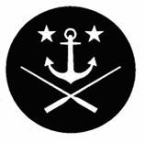

BOC Sun Coast Table

2015 Little Pirates Christmas Zaf
Dec 4th-Dec. 6th
Tariff: $135 Per Person

Ahoy brothers, captives and friends of the Brotherhood of the Coast. The brothers and captives of the Sun Coast Table invite you to attend our Annual Little Pirates Christmas Zaf in the sub-tropical climes of Sarasota/Bradenton Florida. This party continues to be the longest running annual Zaf in the US. So lay in a course for Sarasota/Bradenton to join in the holiday festivities. Prepare to bask in the December sun of FL to celebrate the ushering in of the holiday season in true Brotherhood fashion!

Friday, December 4th, 8-11PM,

LeBarge Tropical Cruises • 2 Marina Plaza, Sarasota FL 34236 • Off Hwy. 41 in Marina Jack Plaza
Dress: Battle Dress (aka Pirate Rig)

Since this is the Brotherhood of the Coast, and we all have a love of the sea, what better way to start the weekend Zaf than on a vessel that will ply Sarasota Bay for three hours while we party hearty!
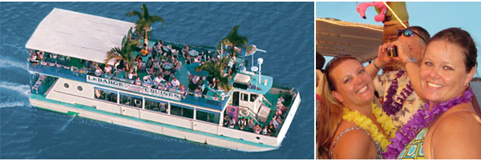

We reserved the entire vessel for the ZAF attendees. Enjoy cruising the placid waters of the bay and dance the night away listening to music under a twinkling sky. LeBarge has four beautiful live palm trees and decorative mermaids on the top deck with an aquarium bar on the lower deck. This 60-foot double-decker boat with indoor and outdoor seating was made to party. A full (cash) bar on each deck will accommodate the thirst of all brothers, captives, and friends. Warning: The Rum Runners are mighty tasty and intoxicating. To complement your chosen grog, we’ll supply the food for the evening cruise. It won’t be overly sophisticated, but you won’t starve!

So let the mermaids lead our way through the tranquil waters of Sarasota Bay and be prepared to “fire broadsides,” and enjoy mucho brotherhood at our “pirate rig dress” informal soiree.

Saturday, Dec. 5th – A day of Recovery & Discovery: You’re free to buddy up with whomever you wish to do as you choose. Some suggestions:

The 38th Annual St. Petersburg Power & Sailboat Show, the largest boat show on the Gulf Coast, is set to sail into the Duke Energy Center for the Arts Mahaffey Theater Yacht Basin and Albert Whitted Park in St. Petersburg, Fla., from Thursday, Dec. 3 through Sunday, Dec. 6, 2015.
The show will feature an impressive selection of power boats and sailboats in water and on land, including a 40,000-square-foot clearspan tent housing all types of marine gear. Show-goers will find hundreds of power boats and sailboats including family cruisers, runabouts, fishing boats, magnificent sailing yachts, personal watercraft and much more. And don’t forget to visit the floating “beer barge” to satiate your thirst.
Tickets: $12 at the gate

SHOW LOCATION: Mahaffey Theater Yacht Basin 400 First Street South St. Petersburg, FL 33701
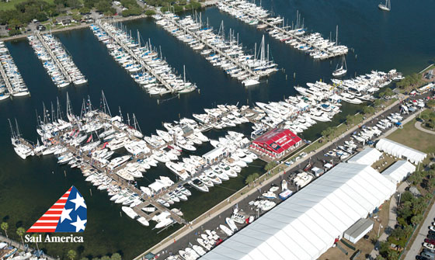

Downtown Sarasota Shopping and Restaurants: Main Street, Sarasota
There are numerous unique shopping opportunities, restaurants, and watering holes located along the quaint downtown venue of Main Street in Sarasota. But watch that your credit card bill doesn’t give you indigestion afterward!!!

Microbrewery Tour in downtown Bradenton, FL
Two micro-breweries have opened in downtown Bradenton, close to McKechnie Field, where the Pittsburg Pirates have spring training, and their minor league affiliate the Bradenton Marauders play during the summer months.

Motorworks Brewery is located at 1014 9th Street West, Bradenton, FL 34205. They have a spacious beer-garden, offer a full bar, and have 10 of their own brewed beers on tap, augmented by twenty other micro-brewed guest taps. Open 11am-midnight (or later). No, they don’t have Bud Light, Miller Lite, or Coors Light, so don’t even ask (and if this is the swill you usually drink, then what the heck are you doing in a micro-brewery to begin with?) Be sure to check out their spacious and inviting Beer Garden (see photo below)!

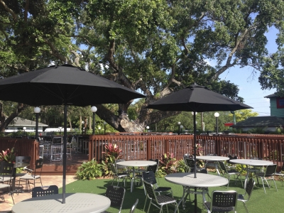

Darwin’s Brewing Company is located at 803 17th Avenue W, Bradenton, FL 34205. Darwin’s was founded with the goals of crafting distinctive indigenous artisan brews and sharing the flavors, culture, and native mystique of South America’s Andean Region with beer lovers around the world. This is a dedicated brew pub (no wine or liquor), but they typically have 12 of their own fresh brewed beers and one or two “guest” taps. Darwin’s opens at noon on the weekends, and 4pm Tuesday-Friday. They are open until midnight.

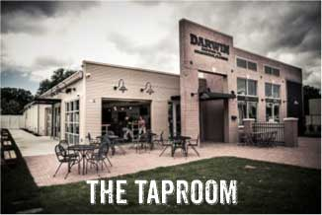

St. Armands Circle: St. Armands Key, Sarasota, FL.

The quintessential tourista locale in our fair corner of FL. Tour the shops, laugh at the prices, and then go have a beer or cocktail at Lynch’s Pub & Grub, while watching well heeled consumers jostle for the inside track to refulgent, ostentatious purchases.

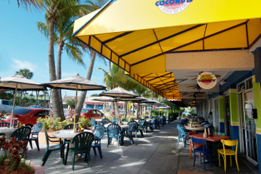

________________________________________________________________________

Saturday, December 5th, 6-10PM – Sarasota Yacht Club
1100 John Ringling Blvd, Sarasota, FL 34236

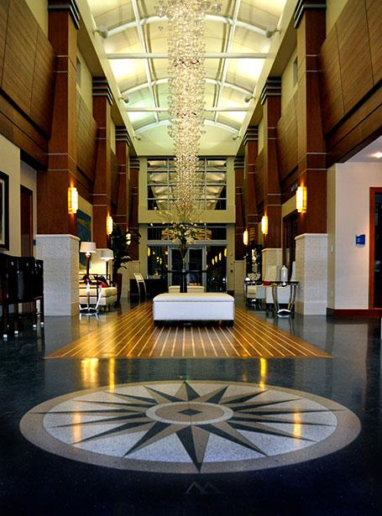

Dress: Formal Attire (blazers and ties for the men, dresses/dress pants for the captives)

The SYC was founded in 1926. It possesses a solid and enviable tradition as a club for yachtsmen and their crews for 89 years.

On April 23, 2010 the Sarasota Yacht Club opened the doors to its newly constructed 23,000 square foot clubhouse that combines a modern nautical architecture with elegance and sophistication.

We’ll start with a cocktail hour (cash bar, and we’ll be selling drink tickets) featuring delectable hors d’oeuvres, followed by formal dinner service with a three course meal.

Also, for the 9th year in a row, the group Sundown will provide music for our formal gathering. So get ready to scratch the tiles and dance your worries away. We are anticipating a fun and memorable evening at this august yacht club!

______________________________________________________________________

Sunday: December 6th, 10am-Noon: Farewell Brunch at The Home of Steve and Jean Herb – 5820 Riegels Harbor Road, Sarasota (Siesta Key), FL 34242

Our farewell Sunday Brunch affair will rely upon the culinary expertise of the Sun Coast Table captives and brothers. The offerings will be home cooked, and the open bar will be ready to quench your thirst with Bloody Marys, Screwdrivers, and Mimosas.

This will be a most casual affair as we bid our guests a fond farewell, safe travels back to their home ports, and a healthy and happy holiday season. We’re sure our brunch buffet will not let you leave the Sun Coast hungry (or thirsty).

______________________________________________________________________

Accommodations

We have berths available for out-of-town brothers on a first come, first served basis. If you are planning to participate, please immediately email Flaco (Joe Vermeren) and tell him what you need (single or double) at gypsyjoe123@gmail.com (phone 941-705-2000). We will do everything we can to find you a berth at the home of a Sun Coast brother. If we run out of berths, we will recommend a centrally located hotel.

Summary

Now you know the details, the places, the events and the cost, so steer a course for Sarasota/Bradenton and take part in the 2015 Annual Little Pirates Christmas Zaf. We hope to see you here for the party!!!!

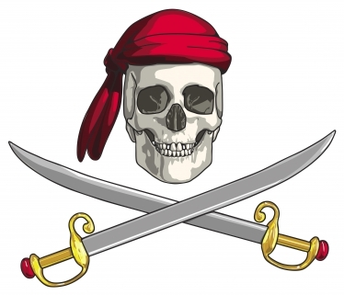

Registration Form for Sun Coast Table Annual Little Pirates Christmas Zaf - December 4th -6th Sarasota/Bradenton FL

Name:

Address:

Table:

Status (brother, captive, engage, guest):

Email Address:

Home Phone:

Mobile Phone:

Name of Captive/Guest:

Do you need accommodations at a Brother’s Home:

Arrival Date and Time:

Departure Date and Time:

Cost of Zaf per person: $135

Make your checks out to Fred Smith, and send your registration form with payment to Fred at
8811 18th Avenue NW, Bradenton, FL 34209

Please send your check no later than November 1st, 2015 (or we’ll keel hual your scurvy visage).

